City of Bastrop Inspection Requirements

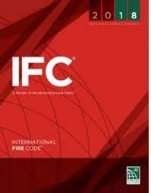

International Fire Code (IFC)

107.1 Inspection Authority
The fire code official is authorized to enter and examine any building, structure, marine vessel, vehicle, or premises for the purpose of enforcing this code
107.2 Inspections
The fire code official is authorized to conduct such inspections as are deemed necessary to determine the extent of compliance with the provisions of this code and to approve reports off inspection by approved agencies.
102.1.1 Approval required
Work shall not be done beyond the point indicated in each successive inspection. Any portions that do not comply shall be corrected, and such portion shall not be covered or concealed until authorized

